READ ME

Using the SRM review routine.

1. Extract data from LIMS using the Data Explorer and the following criteria:

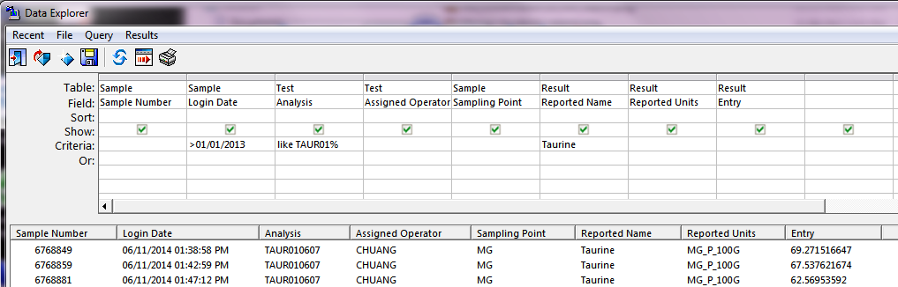

2. Save Excel data to the data folder in SRM_Package set,

3. Open “srm.markdown.R” and change filename to import data file.

4. Change the line 30

“srm_report (data.raw, max.pts = 200, points = 30, doc_type="docx")”

to reflect the number of data points, how many will be used to set the control limits and what type of output is desired. (“html”, “docx”, or “pdf”.).

5. Resultant report will be saved to data/Output folder.